Exp-11:

Grouping:

Create a group from a field in the Data pane

Click on the Sheet Tab and rename it as Group By Header

1.In the **Data** pane, right-click Accessories field and select **Create** > **Group**

2. In the Create Group dialog box, select several members that you want to group, and then click **Group**.

3. The selected members like Accessories, Appliances, Art, Binders, Chairs, Copiers and Envelopes are combined into a single group. A default name is created using the combined member names.

4. To rename the group, select it in the list and click **Rename** Accessories.

5. Drag Sales field on to the Colors Shelf.

6. Drag Accessories field and Sub-Category on to the Rows Shelf.

7. Drag Accessories field onto the Colors Shelf.

8.Right click on Sub-Category from Rows Shelf and select Sort>Then select Descending order.

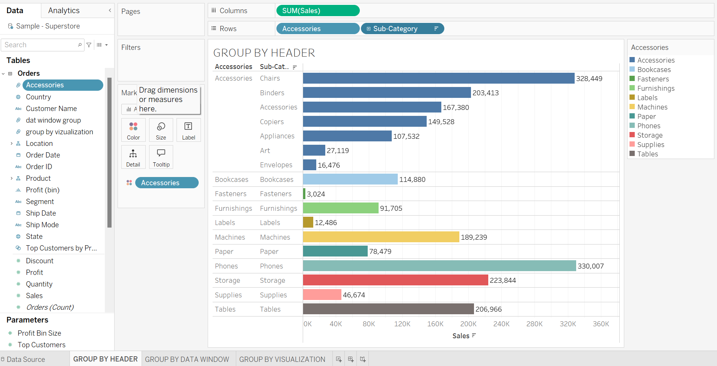

Click on the Sheet Tab and rename it as Group By Data Window:

1.In the **Data** pane, right-click Accessories field and select **Create** > **Group**

2. In the Create Group dialog box, select several members that you want to group, and then click **Group**.

3. The selected members like Binders, Bookcases, Chairs are combined into a single group other members are combined into a other Group.

4. To rename the group, select it in the list and click **Rename** Data Window Group.

5. Drag Sales field on to the Colors Shelf.

6. Drag Data Window Group field and Sub-Category on to the Rows Shelf.

7. Drag Data Window Group field onto the Colors Shelf.

8.Right click on Sub-Category from Rows Shelf and select Sort>Then select Descending order.

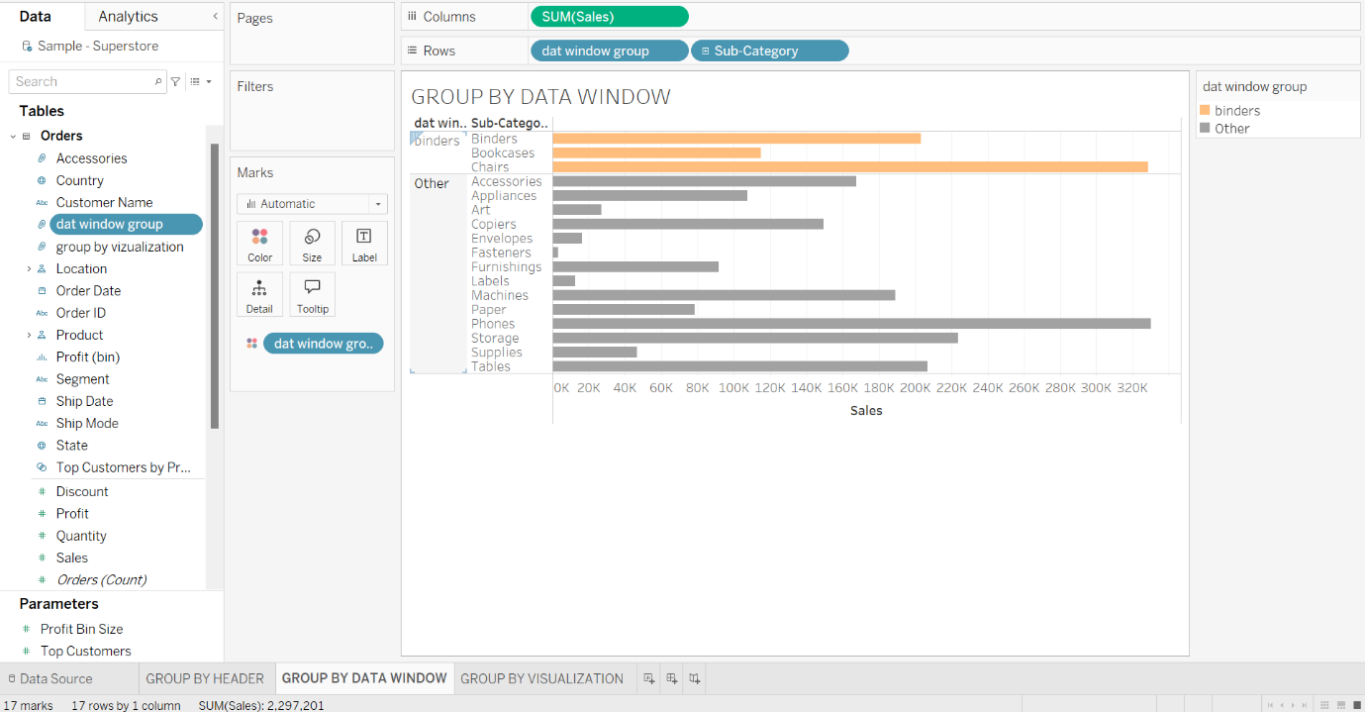

Click on the Sheet Tab and rename it as Group By Visualization:

1.In the **Data** pane, right-click Accessories field and select **Create** > **Group**

2. In the Create Group dialog box, select several members that you want to group, and then click **Group**.

3. The selected members like Chairs & Phones are combined into a single group other members are combined into other Group.

4. To rename the group, select it in the list and click **Rename** Group by Visualization.

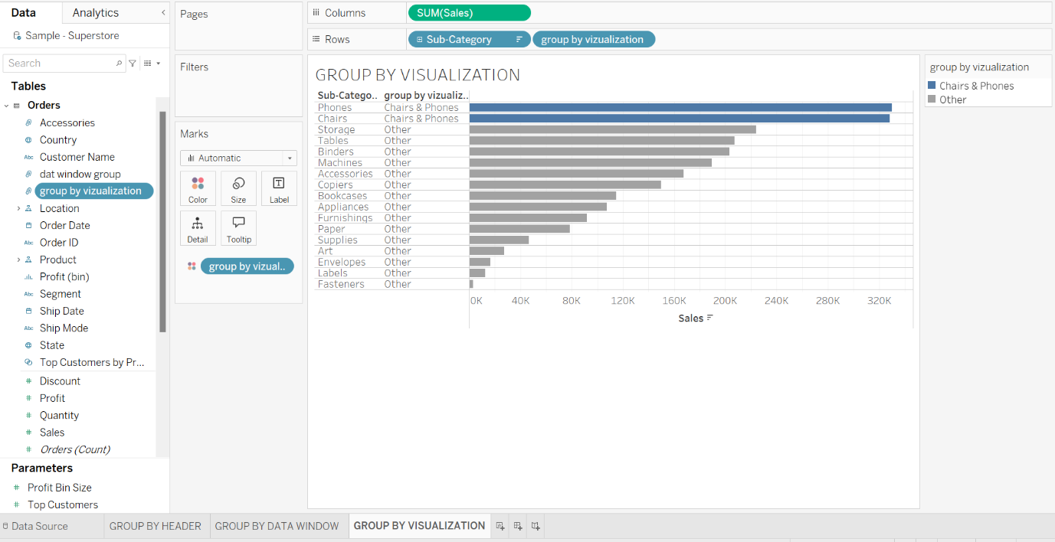5. Drag Sales field on to the Colors Shelf.

6. Drag Group by Visualization field and Sub-Category on to the Rows Shelf.

7. Drag Group by Visualization field onto the Colors Shelf.

8.Right click on Sub-Category from Rows Shelf and select Sort>Then select Descending order.

Create a Set from a field in the Data pane

Click on the Sheet Tab and rename it as Set with Header

1.In the **Data** pane, right-click Sub-Category field and select **Create** > **Set**

2. In the Create Set dialog box, select several members that you want to set, and then click.

3. The selected members like Phones, Chairs, Storage, Tables, Binders are combined into a single set. A default name is created using the combined member names.

4. To rename the set, select it in the list and click **Rename** Set1.

5. Drag Sales field on to the Colors Shelf.

6. Drag Set1 field and Sub-Category on to the Rows Shelf.

7. Drag Set1 field onto the Colors Shelf.

8.Right click on Sub-Category from Rows Shelf and select Sort>Then select Descending order.

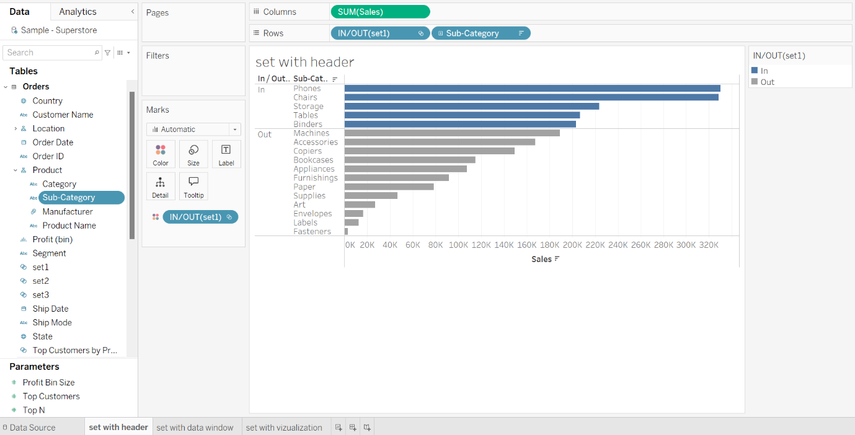

Click on the Sheet Tab and rename it as Bins

1.In the **Data** pane, right-click Quantity field and select **Create** > **Bins**

2. In the Create Bins dialog box, take default New field name Quantity(bin) & Size of bins:2 that you want, and then click ok.

3. Drag Quantity(bin) field on to the Colors Shelf.

6. Drag Quantity field Rows Shelf.

7. Drag Quantity(bin) field & Quantity field onto the Label Shelf.

8.Right click on Sub-Category from Rows Shelf and select Sort>Then select Descending order.

